**Week 1 • From Computers to Java (Beginner‑Friendly v2)**

*This version adds two things people always ask for: a simple‑but‑solid explanation of caching, and a friendly comparison of Java with other popular languages, so you understand why we picked Java for our project.*

# 1) The Big Picture (30‑second refresher)

A computer is like a busy kitchen. The chef (CPU) needs ingredients close by (caches) to cook fast. The pantry (RAM) is farther but bigger. The storeroom (disk) is huge but slow. We give the chef clear instructions using a programming language.

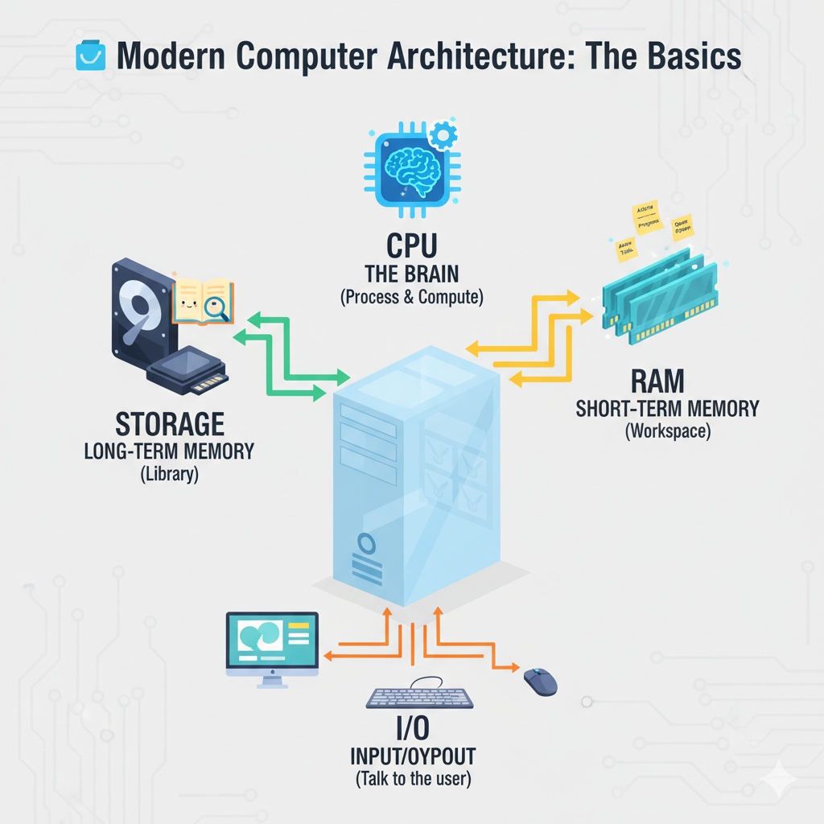

*Figure: CPU ↔ Memory ↔ Storage ↔ I/O — the main pieces you’ll interact with as a developer.*

# 2) Caching — Why Reading in Order Is Fast (Deep but Simple)

Caching is a tiny, super‑fast shelf inside the CPU. It keeps the things you just touched and the things near them. If you use data in order, the CPU can grab many pieces at once. If you jump around randomly, it keeps running back to the pantry.

## 2.1 The idea in one page

* Data travels to the CPU in small boxes called cache lines (think: a small stack of 10–15 nearby pages).
* When you read one piece, the CPU brings the whole small box of nearby pieces with it.
* If your code reads things in order (page 1, 2, 3…), most of what you need is already in that small box → fast.
* If your code jumps around (page 5, then 200, then 37), the CPU must fetch a new box each time → slow.

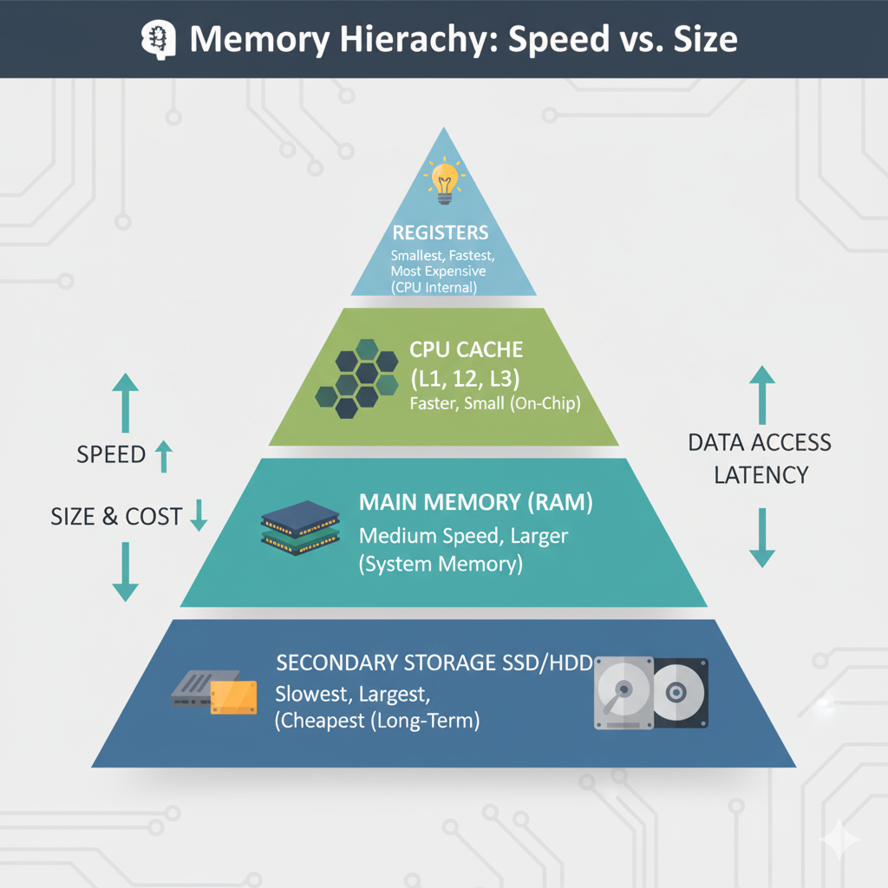

*Figure: Closer = faster (Registers, L1/L2/L3 caches). Farther = slower but bigger (RAM, SSD).*

## 2.2 Two kinds of “being close”

* Spatial closeness: You’ll likely need neighbors of what you just touched (e.g., movie[10] then movie[11]).
* Time closeness: You’ll likely reuse the same thing soon (e.g., checking the same seat status again).

## 2.3 Working set: the golden rule

Your working set is “everything you’re touching right now.” Smaller working sets fit in the fast shelf. When they fit, nearly everything is fast. When they don’t, things are constantly evicted and re‑fetched, which feels slow and “laggy.”

## 2.4 What this means in Java (practical rules)

* Prefer **ArrayList/arrays** for hot loops (data is side‑by‑side) instead of LinkedList (pieces live far apart).
* Prefer **primitives** like int[] over boxed types like Integer[] in hot paths (boxed types create many scattered objects).
* Read/process data **in order**. Avoid random jumps if you can reorganize the data first.
* Process in **chunks** that fit in cache (e.g., handle 10k seats at a time, not 10 million at once).
* Batch file/network operations (fewer, bigger reads/writes keep data nearby).

## 2.5 A tiny experiment (no deep setup needed)

Imagine two tasks:

* Task A: Read numbers from 1 to 1,000,000 in order and add them.
* Task B: Read the same numbers but in a random order and add them.

Even though both add the same numbers, Task A usually finishes much faster. Why? Because Task A marches in order and the CPU’s tiny shelf keeps bringing the next pages automatically.

# 3) Where Java Lives in This Picture (Quick)

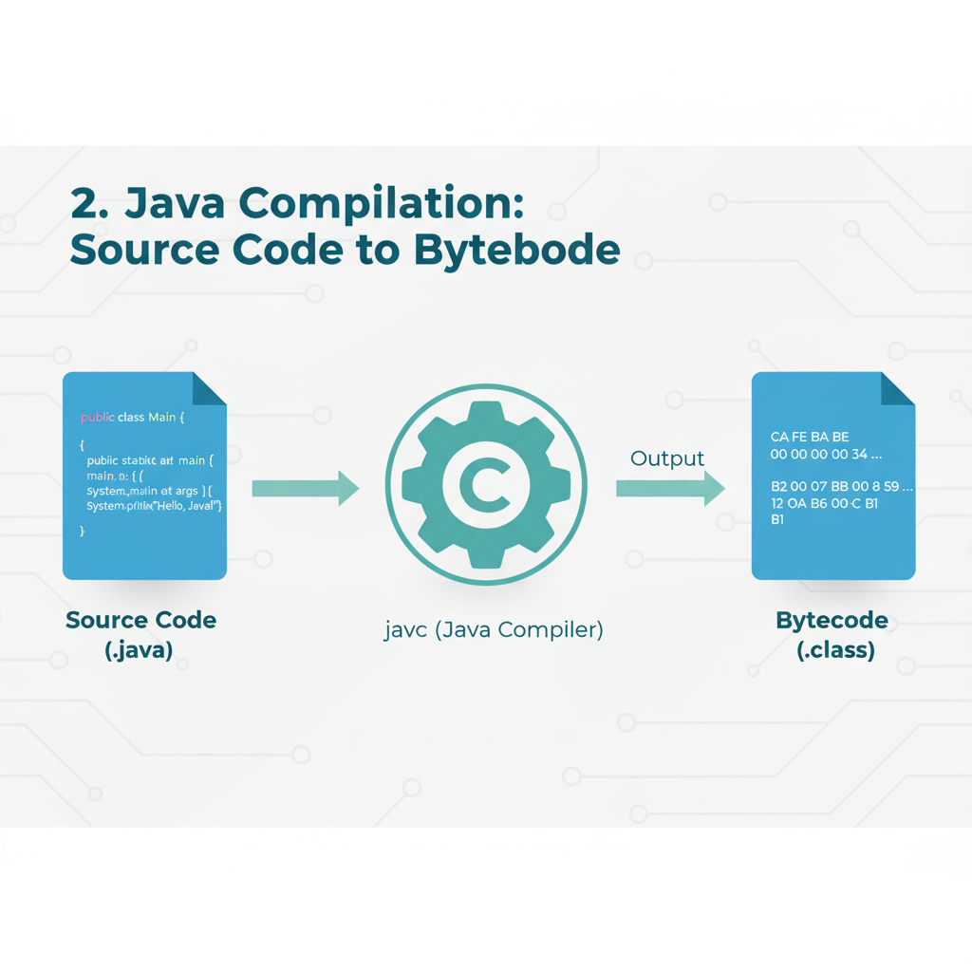

*Figure: You write Java (.java). A compiler creates bytecode (.class).*

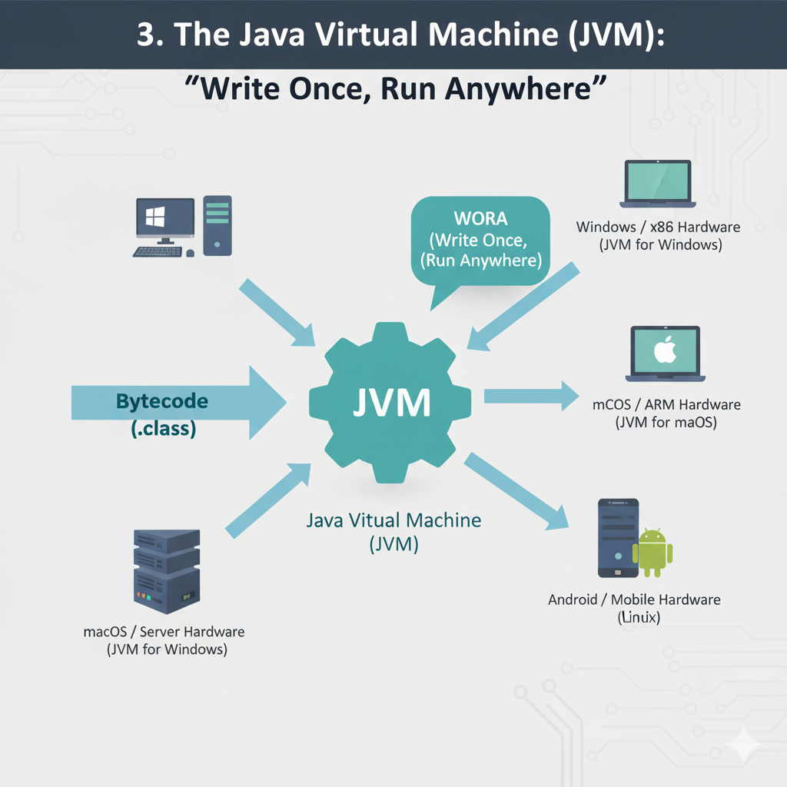

*Figure: The JVM is like a universal projector that can play your bytecode on many machines.*

Java turns your work into a neutral format (bytecode). A helper called the JVM runs that bytecode on any computer. So our CineBook app can run on Windows, Mac, or Linux without changing the code.

# 4) The JVM, Simply Explained

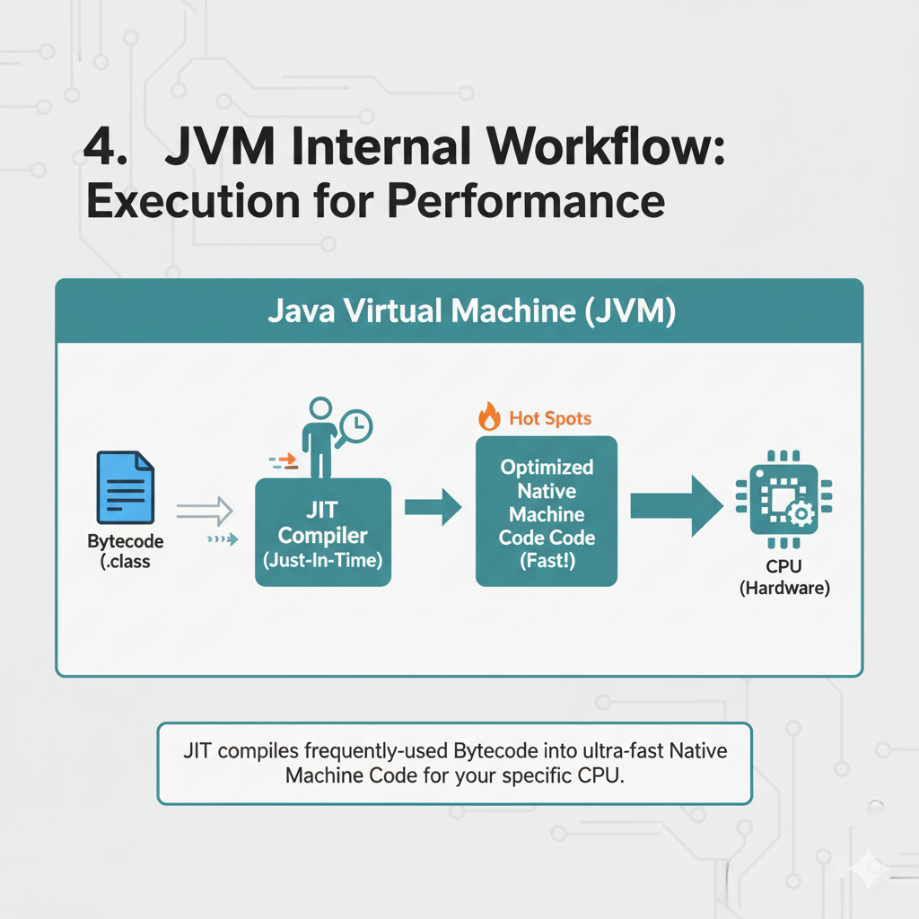

*Figure: The JVM starts running your code immediately, then quietly speeds up busy parts behind the scenes.*

* Starts fast by running your code step‑by‑step.
* Watches which parts are used a lot, then quietly makes those parts faster (so repeated tasks speed up).
* Also cleans up objects you no longer use (called garbage collection), so you don’t have to do manual cleanup.

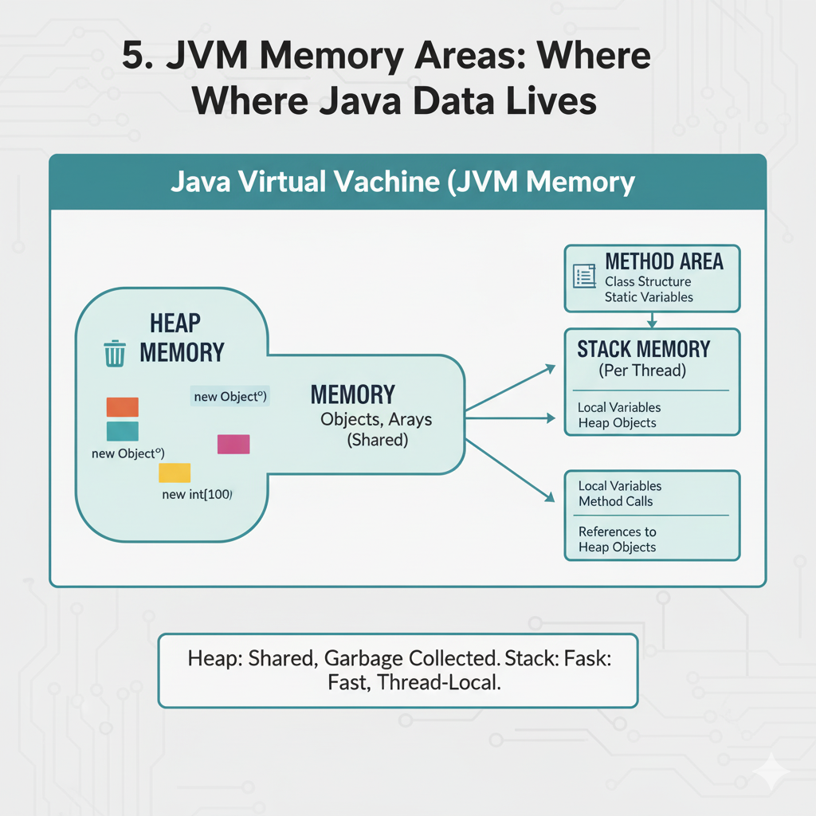

*Figure: Inside the JVM: small, private trays (stacks), a common counter (heap), and a recipe book (metaspace).*

# 5) Java vs Other Popular Languages (Beginner‑Friendly Map)

Different languages are like different kitchen styles. All can cook; each shines for certain dishes. Here’s a friendly map so you know when Java is a good bet—and when something else might be easier.

| Language | Feels Like | Shines At | Why People Pick It | Watch Out For |
| --- | --- | --- | --- | --- |
| Java | Clear, structured, strongly typed | Backends, big systems, Android servers | Runs anywhere; fast once warmed; great tools; safe by default | More words than Python; a little setup at first |
| Python | Very quick to write | Data/ML, scripts, small tools | Huge ML libraries; easy to try ideas | Usually slower for heavy compute; packaging/envs can be tricky |
| Go | Simple and tidy | Small fast services, cloud tools | Tiny single-file apps; fast startup | Fewer features; simpler generics |
| Node.js (JS) | Great for web & realtime | APIs + front-end team synergy | One language for front & back; npm ecosystem | Single-threaded by default; callbacks/promises to learn |
| Rust | Super fast & safe | Systems, performance‑critical parts | Memory safety + speed | Steeper learning curve at the start |
| Kotlin | Modern, concise Java‑friend | Android, modern backends | Interoperable with Java; fewer words | You still need JVM basics; not in every org yet |

For **CineBook**, Java gives us:

* Reliable performance and easy growth for lots of users.
* Strong structure so big features don’t become messy.
* Great ecosystem (Spring, testing, logging) used by many companies.

# 6) Your First Tiny Java Program

Let’s say hello. You’ll type this in your editor and run it. Don’t worry—next week we’ll unpack every word.

public class Main {  
 public static void main(String[] args) {  
 System.out.println("🎬 Welcome to CineBook!");  
 }  
}

# 7) Easy Do’s & Don’ts You Can Remember

* Do read/process data in order when possible (it’s naturally fast).
* Do keep programs small and clear; use helpful names.
* Don’t create lots of short‑lived objects inside tight loops.
* Don’t panic about speed on day 1—make it work, then make it neat, then make it fast.

# 8) Mini Glossary

* Cache — A tiny, super‑fast shelf inside the CPU that keeps what you just used and things near it.
* Cache line — The small box the CPU brings at once (think: a handful of nearby pages).
* Cache hit/miss — Hit: the piece you need is already on the shelf. Miss: you must walk back to the pantry.
* Working set — Everything you’re touching right now. Smaller working sets stay in the fast shelf.
* JVM — The helper that runs Java bytecode on any computer.
* Bytecode — A neutral format your Java turns into before running.